ServiceNow Flow Designer Project
Project Documentation
1. Introduction
• Project Title: Streamlining IT Procurement: Automating Standard Laptop Orders with Flow Designer
• Team ID: SWTID-2026-2617 (Team size: 4)
• Team Members: Goushikram G - Team Leader; Santhosh Karthick A - Team Member; Jason Selvin Raj J - Team Member; Abutharick M - Team Member.
• Date: 30 September 2026
2. Project Overview
• Purpose: Standard laptop requests need a configuration step that is easy to overlook or delay. The project automates this: once a Standard Laptop is ordered and approved, a configuration task is created and assigned to the Hardware team automatically. Goals: timely configuration for users, less manual work and fewer errors, better use of IT staff, and higher efficiency in IT procurement.
• Features: Flow "Standard laptop task" (Application: Global, Run As: System User); Service Catalog trigger; Create Catalog Task action (short description and description "Laptop needs to Configured", Assignment group = Hardware, Approval = Approved); flow attached to the Standard Laptop catalog item; ordering through Service Catalog > Hardware > Standard Laptop; automatic catalog task visible under the Requested Item.
3. Architecture
• Frontend: No custom front end (React is not used). Users work in the ServiceNow Service Catalog (Hardware > Standard Laptop > Order Now), the Order Status page, and the Request, Requested Item and Catalog Task forms.
• Backend: No Node.js/Express. The logic is a Flow Designer flow: Service Catalog trigger followed by the Create Catalog Task action (ServiceNow Core), running as System User in the Global application.
• Database: ServiceNow platform tables instead of MongoDB: Request, Requested Item, Catalog Item (Standard Laptop) and Catalog Task [sc_task]. The flow writes Short description, Description, Assignment group and Approval on the Catalog Task.
4. Setup Instructions
• Prerequisites: A ServiceNow instance; an admin (System Administrator) account; Flow Designer under Process Automation; the Standard Laptop item in the Hardware category of the Service Catalog; a Hardware assignment group. (Node.js and MongoDB are not needed.)
• Installation / Configuration: Milestone 1 - All > Flow Designer > New > Flow; name "Standard laptop task", Application Global, Run As System User, Submit; Add a trigger > Service Catalog > Done; Add an action > Create Catalog Task; drag the Requested Item record into Request Item; set the short description and the Description, Assignment group (Hardware) and Approval (Approved) field values; Done; Save; Activate (confirm Activate). Milestone 2 - All > Maintain Items > Standard Laptop > Process Engine; remove other automations, add the flow and save the record.
5. Folder Structure
• Client: Not applicable - there is no source folder. The user-facing pieces are configuration records: the Standard Laptop catalog item and its catalog page.
• Server: Not applicable - there is no server code. The automation lives in one configuration record, the flow "Standard laptop task" in Flow Designer.
6. Running the Application
• Steps: Instead of npm commands, run the scenario in the UI: All > Service Catalog > Hardware > Standard Laptop > Order Now.
• Approve: Open the Request Number (REQ0010001) > Approvers tab, right-click the approval and choose Approve.
• Verify: Open the Requested Item (RITM0010001) > Catalog Tasks > open SCTASK0010001 and check the short description and the Hardware assignment group.
7. API Documentation
• Endpoints: No custom REST endpoints are exposed. The flow is event-driven.
• Trigger: Service Catalog - fires when a catalog item with this flow attached is ordered.
• Action: Create Catalog Task - inputs: Requested Item (from the trigger), Short description "Laptop needs to Configured", Fields: Description, Assignment group = Hardware, Approval = Approved. Output: a Catalog Task record (e.g. SCTASK0010001).
8. Authentication
• Access: Users sign in to the ServiceNow instance with their own accounts; the request is approved by the approver shown on the Approvers tab.
• Flow execution: The flow runs as System User, so the task is created regardless of the ordering user's permissions. No tokens or custom sessions are implemented.
9. User Interface
Flow properties, trigger and action configuration:
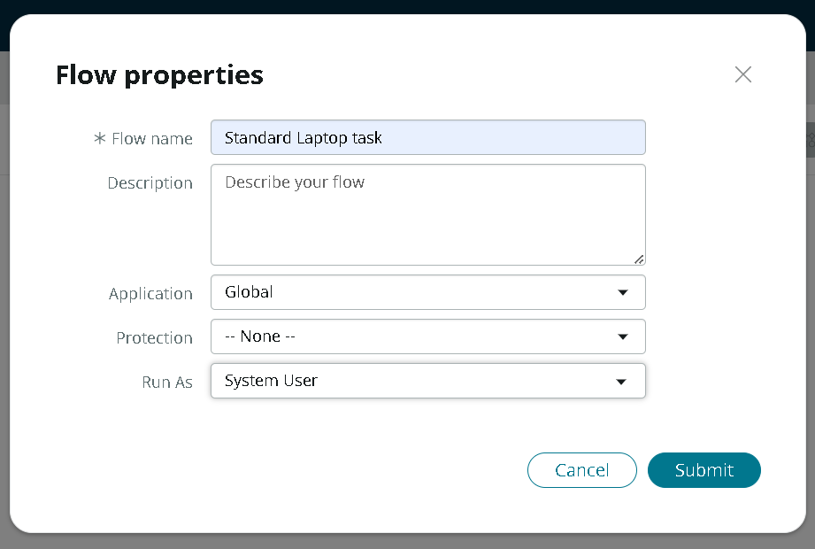
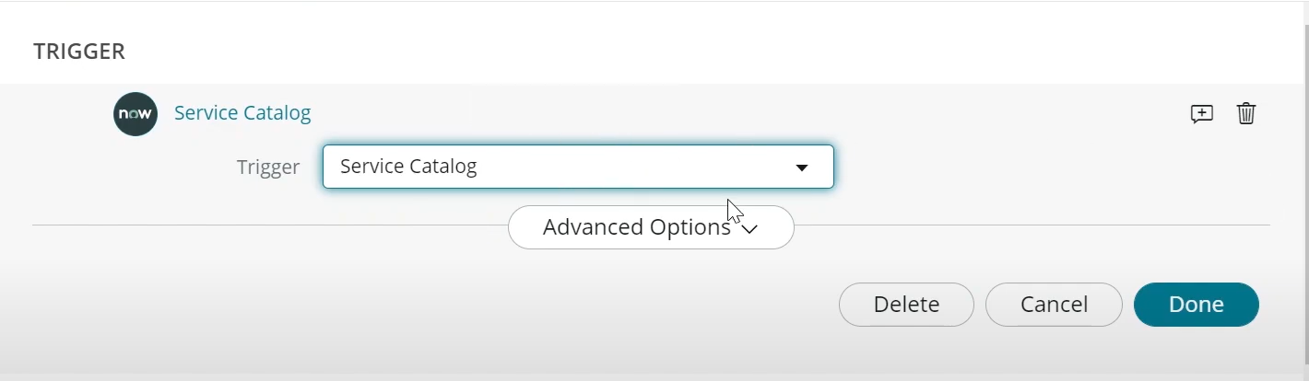
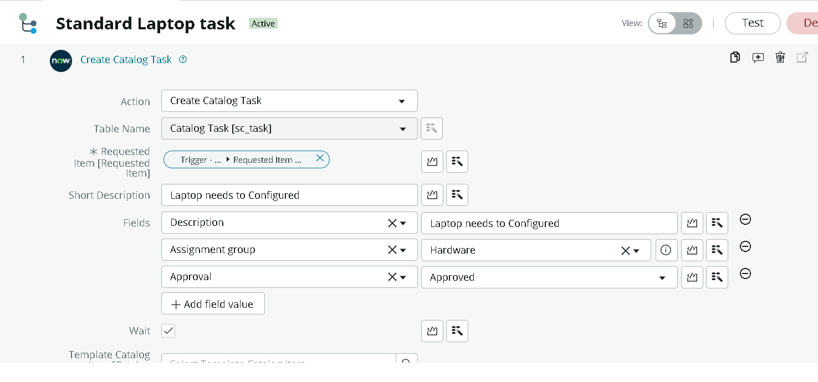
Flow assignment to the catalog item:
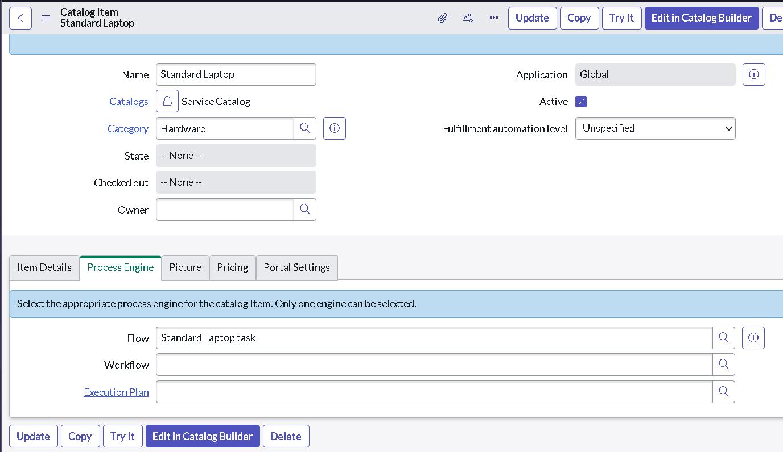
10. Testing
• Strategy: Manual end-to-end functional testing and user acceptance testing in the ServiceNow UI: create and activate the flow, attach it to the catalog item, order a Standard Laptop, approve it and confirm the catalog task. All six functional checks passed; negative and load scenarios were not tested (see the UAT and functional-testing documents).
• Tools: ServiceNow Flow Designer, Service Catalog and the platform record forms.
11. Screenshots or Demo
Ordering, approval and generated catalog task:
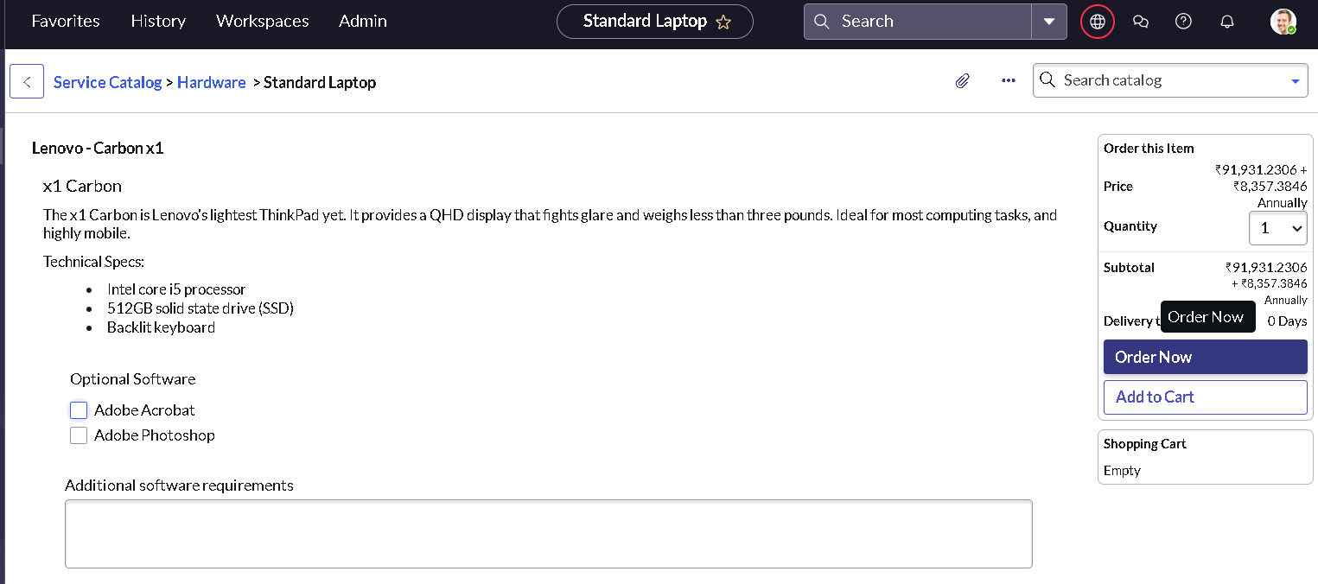
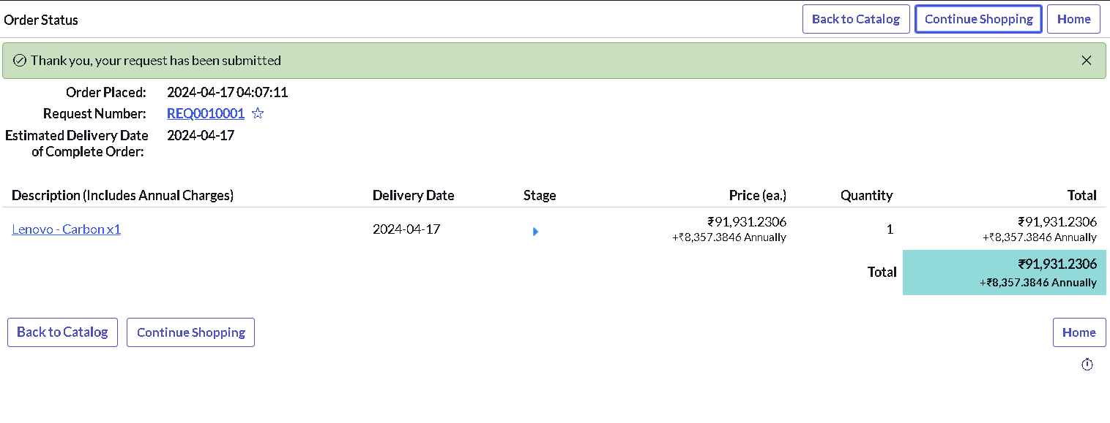
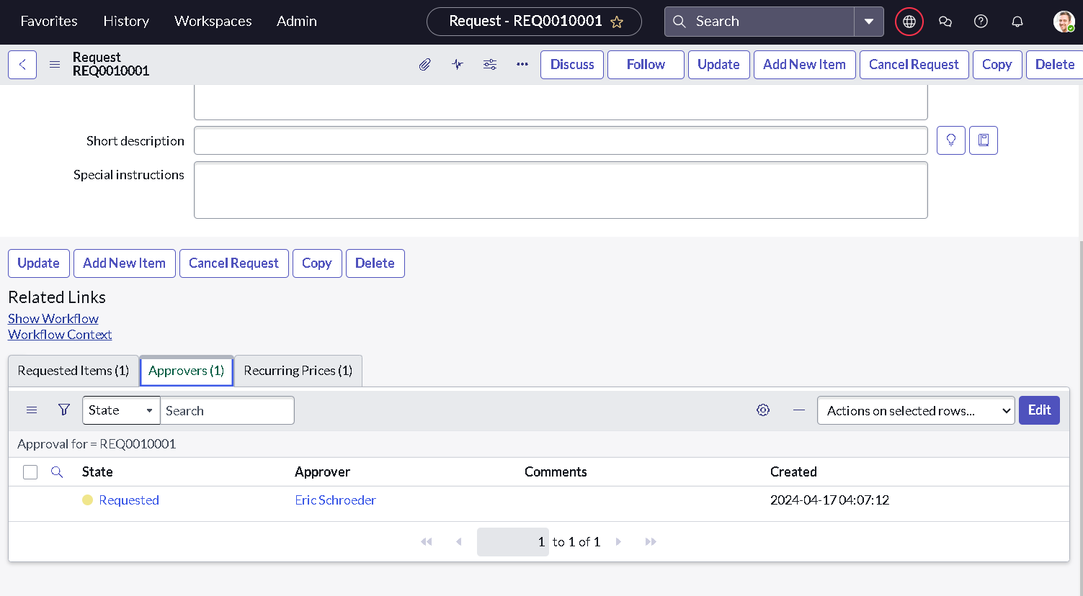
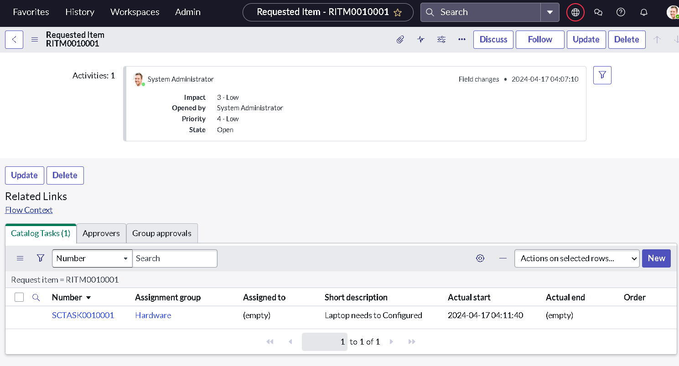
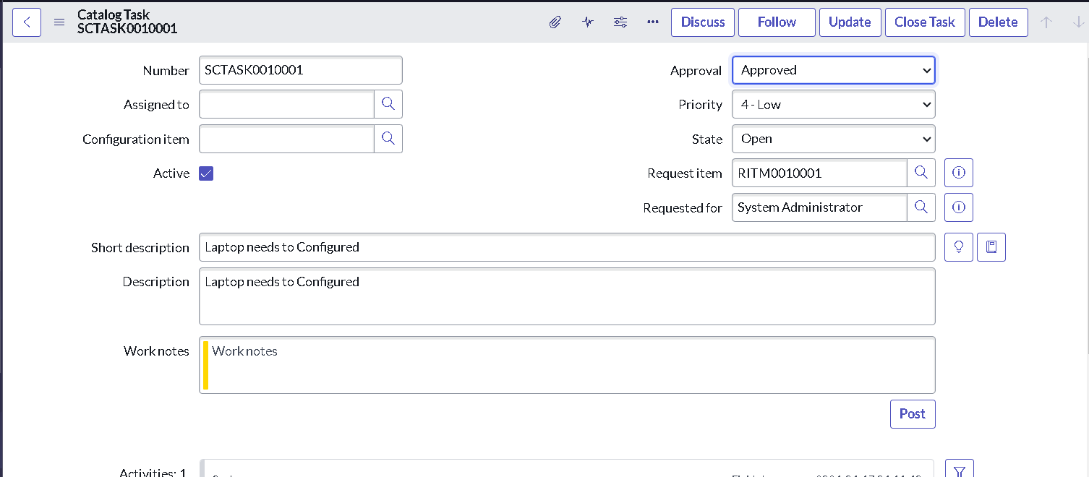
• Demo / reference video: https://youtu.be/3nsUWtzpDz4
12. Known Issues
• Wording: Instructions say "Laptop need to Configured" while the application shows "Laptop needs to Configured".
• Naming: The flow name is written "Standard laptop task" and "Standard Laptop Task" in different places.
• Approval handling: The documented flow has only the Create Catalog Task action; the Approval field on the task is set statically to "Approved" rather than by an approval step in the flow.
• Testing gaps: Negative scenarios and multiple/simultaneous orders were not tested.
13. Future Enhancements
• Proposed: Add an approval step in the flow; email notification to the Hardware group; automatic assignment to a technician; SLA tracking for configuration time; extend the same pattern to other standard devices.

